Government of Jamaica
Implementation of the Supplier Registration System
For the National Contracts Commission

D4 End-user Supplier Manual

Issue 1.0

Version 1.0

EUROPEAN DYNAMICS S.A.

Modification History

Date | Version | Author | Comments
05/12/2018 | 1.0 | ED | Initial version

Table of Content

1 Main Page 8
2 PPC Registration 9
2.1 Fill in “My PPC Profile” 9
2.1.1 Fill in “General Profile” tab 9
2.1.2 Fill in the “Operational Profile” tab 13
2.1.3 Fill in the “Financial Profile” tab 18
2.1.4 Fill in the “Projects Profile” tab 21
2.1.5 Fill in the “Personnel Profile” tab 24
2.1.6 “Documents Profile” tab 28
2.1.7 “Site Visits” tab 29
2.1.8 “Notes” tab 30
2.1.9 “Payments” tab 30
2.2 Apply for a New Registration Process 31
3 Apply for renewal 33
4 Apply for an Additional Category 35
5 Apply for Works Upgrade 37
6 List of Registrations 39
7 List of Transactions 40

Table of Figures

Figure 1: Main Page 8
Figure 2: PPC Registration Menu 9
Figure 3: Complete General Profile 10
Figure 4: Add Insurance, General Profile 10
Figure 5: Add Insurance fields to be completed 11
Figure 6: Add Reference, General Profile 11
Figure 7: Add Reference fields to be completed 12
Figure 8: Operational Profile/General View 13
Figure 9: Branches Section 14
Figure 10: Manage Branches/Complete the Fields 15
Figure 11: Associated/Affiliated Organizations Section 15
Figure 12: Associated/Affiliated Organizations fields 16
Figure 13: Special Awards Section 16
Figure 14: Special Awards fields 16
Figure 15: Key Customer/Supplier Section 17
Figure 16: Key Customers/Suppliers fields 17
Figure 17: Plant and Equipment Item section 17
Figure 18: Plant and Equipment fields 18
Figure 19: Financial Profile View 18
Figure 20: Add Annual Financial 19
Figure 21: Annual Financial Fields 19
Figure 22: Add Financial Institution 20
Figure 23: Financial Institution Fields 20
Figure 24: Projects Profile View 21
Figure 25: Add a New Project View 21
Figure 26: Add a new Project 22
Figure 27: Additional Project Profile Sections 22
Figure 28: Project team/Stakeholders view 23
Figure 29: Add Project Team/Stakeholder 23
Figure 30: Project Locations View 23
Figure 31: Add Project Location Fields 24
Figure 32: Personnel Profile 24
Figure 33: Press the "Add” button to add personnel profile 24
Figure 34: Add Personnel Fields 25
Figure 35: Additional Personnel Profile Entries 26
Figure 36: Associated/Affiliated Organization fields 26
Figure 37: Add Qualification fields 27
Figure 38: Add License Fields 27
Figure 39: Add Project Experience fields 28
Figure 40: Documents Profile tab view 28
Figure 41: Add a document window 29
Figure 42: Site Visits tab 30
Figure 43: Notes tab 30
Figure 44: Payments tab 31
Figure 45: Apply for a New Registration Option 31
Figure 46: Apply for a New Registration fields to be completed 32
Figure 47: Apply for Renewal option 33
Figure 48: Renewal screen 33
Figure 49: Apply for renewal final 34
Figure 50: Apply for an Additional Category option 35
Figure 51: Apply for an Additional Category Section 35
Figure 52: Additional category selection 36
Figure 53: Where to select categories 36
Figure 54: Apply for Works Upgrade Option 37
Figure 55: What to select in order to apply for a new registration 37
Figure 56: Apply for Works Upgrade 38
Figure 57: Error in grades recommendation 38
Figure 58: List of Registrations option 39
Figure 59: List of Registrations 39
Figure 60: List of Transactions option 40
Figure 61: List of Transactions 40
Table of Tables

No table of figures entries found.
Acronyms / Abbreviations

Acronym / Abbreviations | Meaning
ED | European Dynamics SA
e-PPS | European Dynamics electronic Public Procurement System
MoF | Ministry of Finance
NCC | National Contracts Commission
PAPU | Procurement and Asset Policy Unit
PPC | Public Procurement Commission
PPCD | Public Procurement Committee Director
PPCC | Public Procurement Committee Coordinator
PPCO | Public Procurement Committee Officer
PE | Procuring Entity
SA | System Administrator
TAJ | Tax Administration of Jamaica
TCC | Taxation Compliance Certificate
TRA | Tax Registration Authority
TRN | Tax Registration Number
XLS | Microsoft 2003 Excel Spreadsheet

Main Page
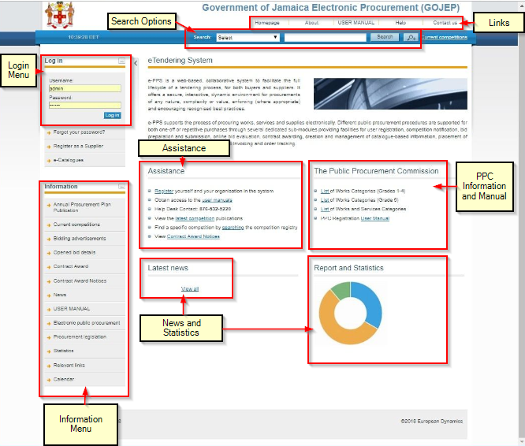
Figure 1: Main Page

The main page of the e-GP system consists of the following elements:
- Left column, which contains the Login panel, General Information Panel, and Calendar Panel.
- Central column, which contains general information regarding the system, the Suppliers and the users of procuring entities. Furthermore, assistance and it lists any uploaded news and also statistical information about the system usage.
- Constant functionality at the top of the main page which contains functionalities which are available within all pages of e-GP.
- Constant functionality at the bottom of the main page which contains functionalities which are available within all pages of e-GP.

PPC Registration
When a Supplier Administrator user is logged in, the NCC module permits the user to register as a PPC Supplier. In order to register, user has to fill in the PPC Profile at first and then select the “Apply for a New Registration” option. (Figure 2)
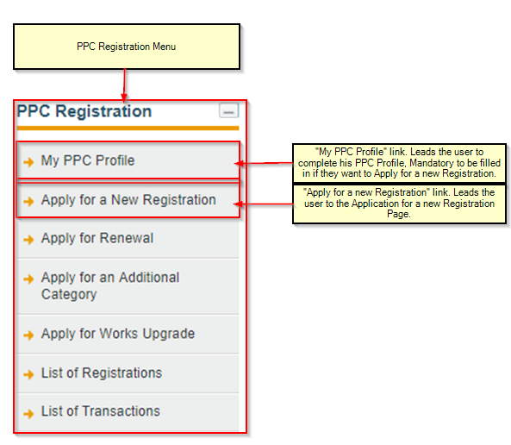
Figure 2: PPC Registration Menu

Fill in “My PPC Profile”
In the first phase of the procedure, the Supplier Administrator user must be logged in.
The next step would be to fill in the PPC Profile, selecting the “My PPC Profile” option.

Fill in “General Profile” tab
When the user sees the General Profile tab, they will have to complete -at least- all the mandatory information. The other fields will be prepopulated, from the Supplier Organization Registration data that the user completed during the registration process of the Company.
In the end, they have to press the “Save” button.
The information required to be completed is:
- Date of Registration (Mandatory)
- GCT Registration Number
- Website (Mandatory)

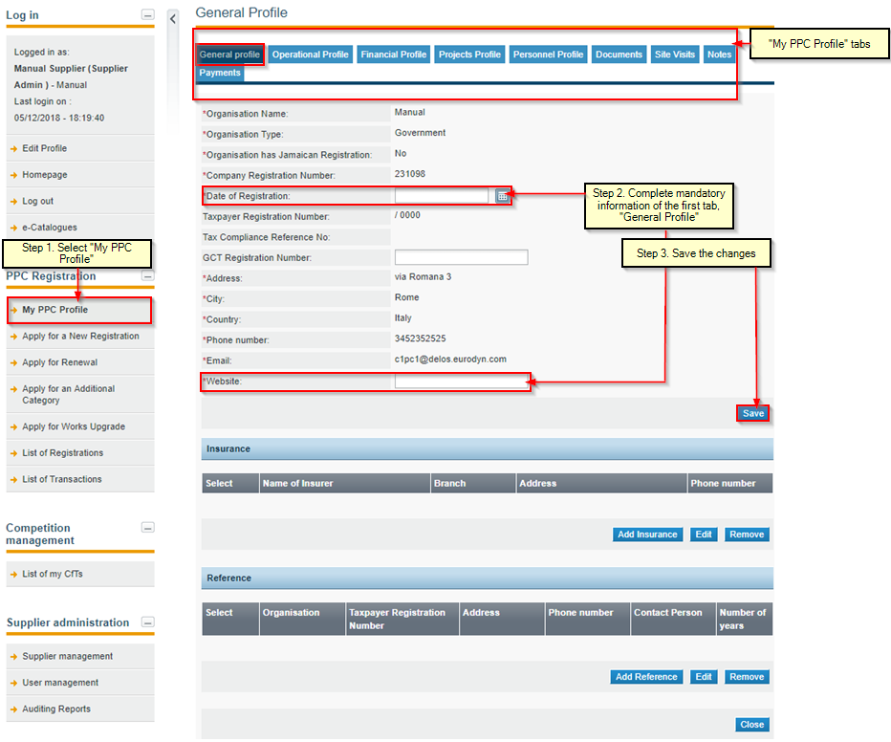
Figure 3: Complete General Profile

After saving the General information, the user will have to complete Insurance and Reference sections, though it is not necessary.

- Insurance section:

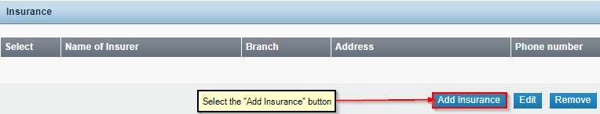
Figure 4: Add Insurance, General Profile

The following image shows what a user sees when pressing the “Add Insurance” button.
The fields that need to be completed are:
- Name if Insurer (Mandatory)
- Branch
- Address (Mandatory)
- Phone number

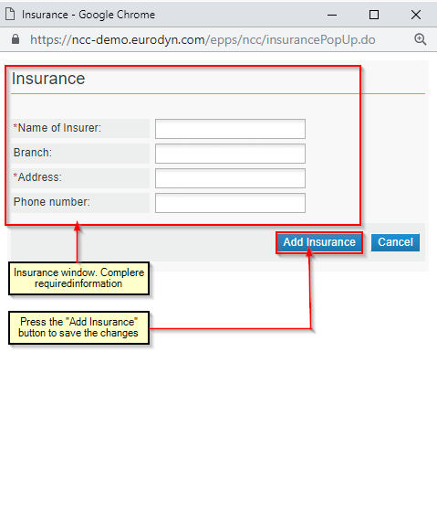
Figure 5: Add Insurance fields to be completed

- Reference Section:

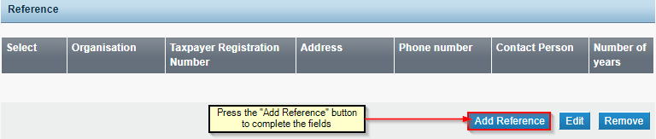
Figure 6: Add Reference, General Profile

The following image shows what a user sees when pressing the “Add Reference” button.
The fields that need to be completed are:
- Organization (Mandatory)
- Taxpayer Registration Number (Mandatory)
- Address (Mandatory)
- Phone number
- Contact Person (Mandatory)
- Number of years (Mandatory)

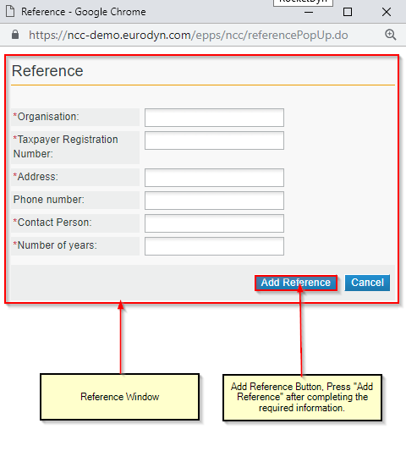
Figure 7: Add Reference fields to be completed

After completing all the previous, the General Profile tab is now completed.

Fill in the “Operational Profile” tab
When the user sees the Operational Profile tab, they will have to complete –at least- all the mandatory information. In the end, they have to press the “Save” button.

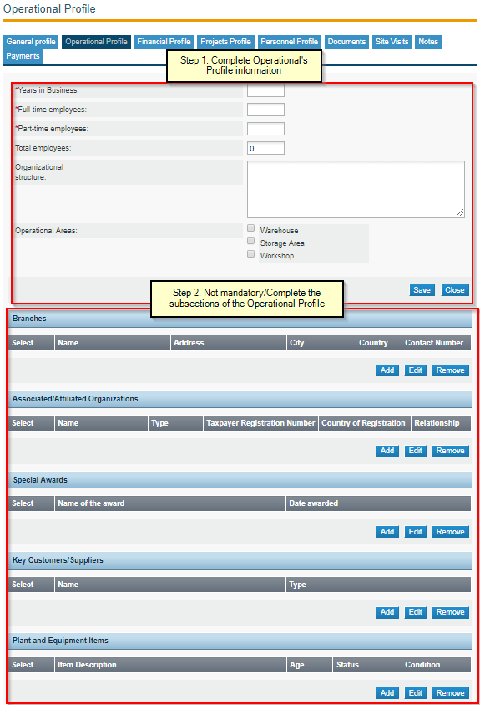
Figure 8: Operational Profile/General View

The information required to be completed is:
- Years in Business
- Full-time employees
- Part-time employees
- Total employees
- Organizational structure
- Operational Areas
- Warehouse
- Storage
- Area Workshop
After completing the mentioned fields, user must press “Save” or “Cancel”, depending of the action they want to do afterwards.

There are some more sections that can be completed under the Operational Profile, which are:
- Branches
- Associated/Affiliated Organizations
- Special Awards
- Key Customers/Suppliers
- Plant and Equipment Items

- Branches
The user must press the “Add” Button to add a Branch.
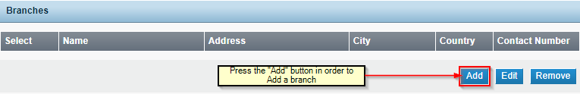
Figure 9: Branches Section

The fields that a user can complete are the following:
- Name (Mandatory)
- Address
- City
- Country
- Contact Number (Mandatory)
The fields are contained in the following figure (Figure 10).
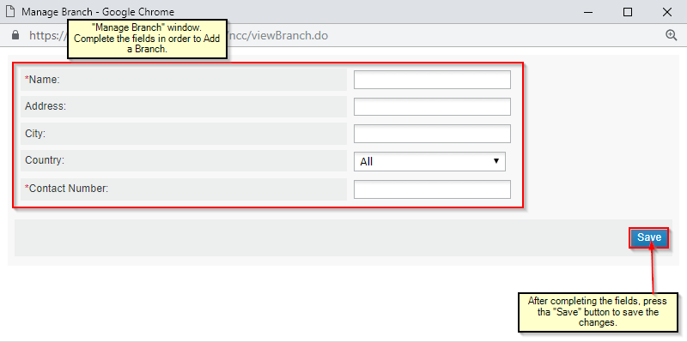
Figure 10: Manage Branches/Complete the Fields

- Associated/Affiliated Organizations
The user must press the “Add” Button to add an Associated/Affiliated Organization.
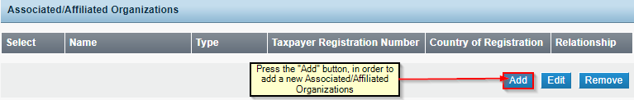
Figure 11: Associated/Affiliated Organizations Section

The fields that a user can complete are the following:
- Name (Mandatory)
- Type (Mandatory)
- Taxpayer Registration Number (Mandatory)
- Country of Registration (Mandatory)
- Relationship (Mandatory)
- Website
- Email
The fields are contained in the following figure ( Figure 12):
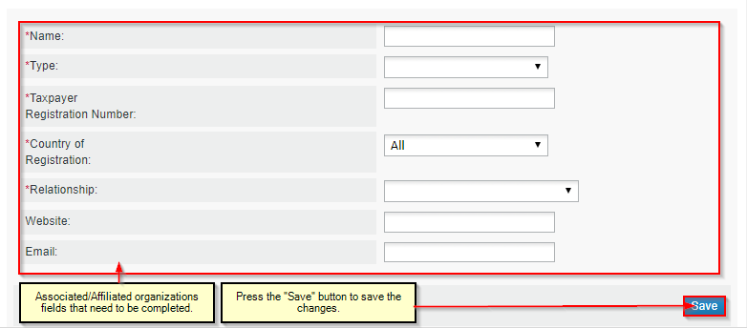
Figure 12: Associated/Affiliated Organizations fields

- Special Awards
The user must press the “Add” Button to add a Special Award.
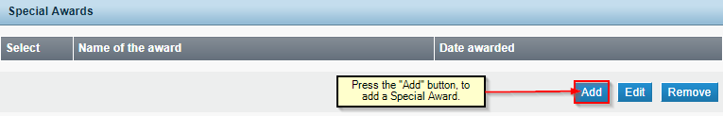
Figure 13: Special Awards Section

The fields that a user can complete are the following:
- Name of the award (Mandatory)
- Date awarded (Mandatory)
The fields are contained in the following figure (Figure 14).

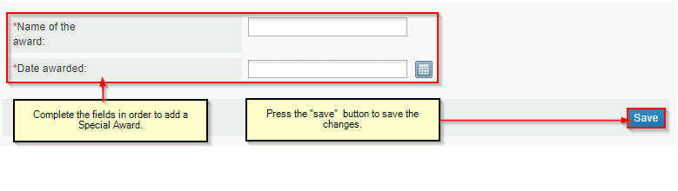
Figure 14: Special Awards fields

- Key Customers/Suppliers
The user must press the “Add” Button to add a Key Customer/Supplier.
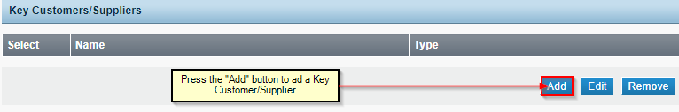
Figure 15: Key Customer/Supplier Section

The fields that a user can complete are the following:
- Name (Mandatory)
- Type (Mandatory)
The fields are contained in the following figure (Figure 16).
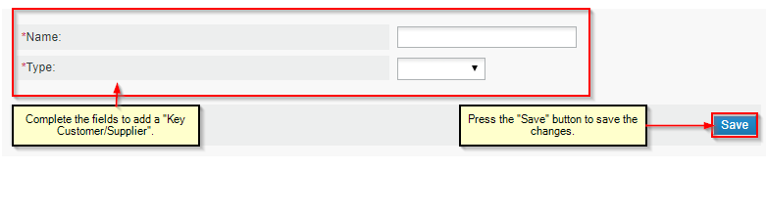
Figure 16: Key Customers/Suppliers fields

- Plant and Equipment Items
The user must press the “Add” Button to add a Plant and Equipment Item.
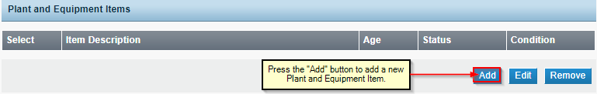
Figure 17: Plant and Equipment Item section

The fields that a user can complete are the following:
- Item Description
- Item ID Number
- Item ID Type
- Age
- Status
- Condition
The fields are contained in the following figure (Figure 18Figure 18).

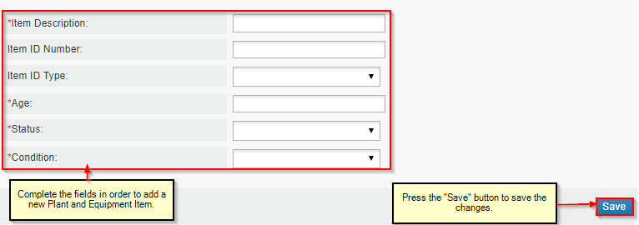
Figure 18: Plant and Equipment fields

*All of the previous sections have the options of editing and removing items already added.
After completing all the previous, the Operational Profile tab is now completed.

Fill in the “Financial Profile” tab
When the user sees the Financial Profile tab, they will have to complete the two sections included. These are Annual Financial and Financial Institution.

This is what a user must see, when pressing in the Financial Profile tab:

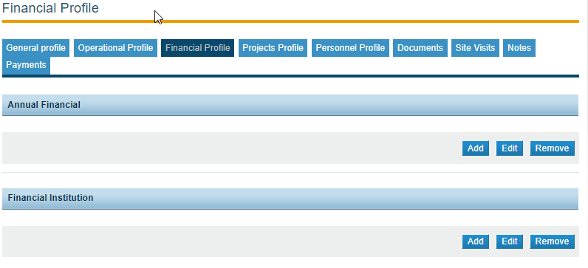
Figure 19: Financial Profile View

- Add Annual Financial
In order to add an entry in Annual Financial, press the “Add” button.
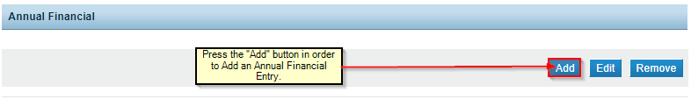
Figure 20: Add Annual Financial

In this section, the fields that a user can complete are the following:
- Start Financial Year
- End Financial Year
- Fixed Assets:
- Current Assets
- Current Liabilities
- Current Ratio
- Annual Sales
- Currency
- Total Value of Construction Work

The fields can be seen as in the following figure (Figure 21Figure 21).
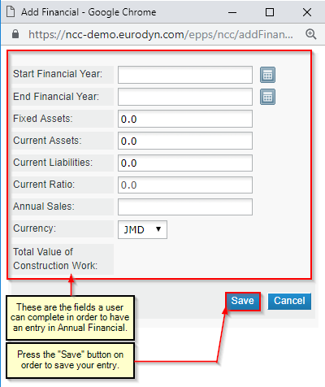
Figure 21: Annual Financial Fields

- Add Financial Institution
In order to add an entry in Financial Institution, press the “Add” button.
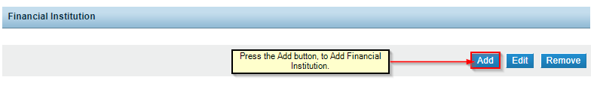
Figure 22: Add Financial Institution

In this section, the fields that a user can complete are the following:
- Name
- Branch
- Address
- Phone number
- Contact Name
- Contact Role

The fields can be seen as in the following figure (Figure 23).
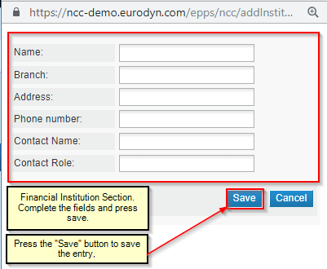
Figure 23: Financial Institution Fields

*All of the previous sections have the options of editing and removing items already added.
After completing all the previous, the Financial Profile tab is now completed.

Fill in the “Projects Profile” tab
When the user goes to the Projects Profile tab, in order to complete all the information required for this profile, they must select “Add Project”.

This is what a user should see when entering the “Projects Profile” for the first time.
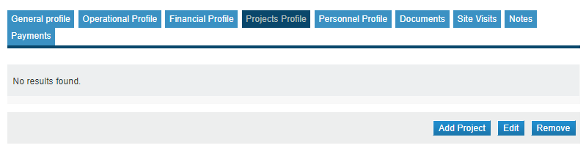
Figure 24: Projects Profile View

- Add a New project
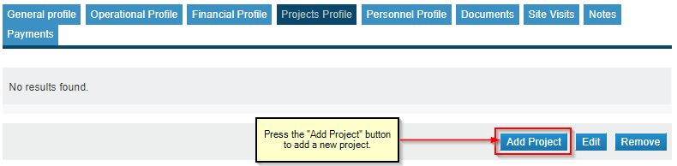
Figure 25: Add a New Project View

In this section, the fields that a user can complete are the following:
- Name (Mandatory)
- Location
- Description (Mandatory)
- Value of Work Executed (Mandatory)
- Work executed as (Mandatory)
- Contract Period
- Start Date (Mandatory)
- Calendar Completion Date (Mandatory)
- Calendar Expired
- Largest Recent Project
The fields can be seen as in the following figure (Figure 26):

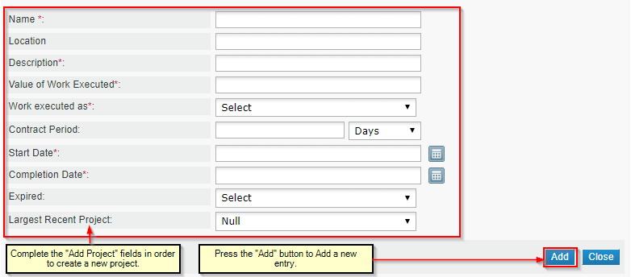
Figure 26: Add a new Project

- Once a new project is added, new fields appear, regarding the Project Team/Stakeholders and the Project Locations.

- Some examples can be seen below, in the following screenshot:

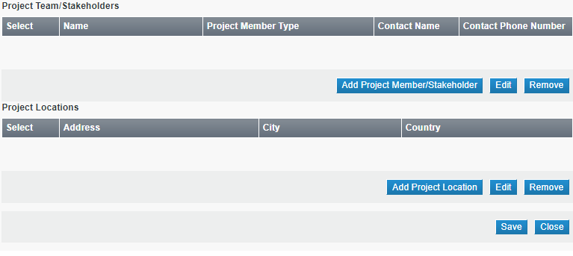
Figure 27: Additional Project Profile Sections

- Project Team/Stakeholders

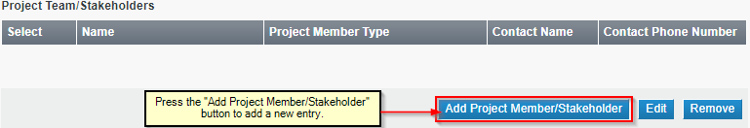
Figure 28: Project team/Stakeholders view

In this section, the fields that a user can complete are the following:
- Name (Mandatory)
- Project Member Type (Mandatory)
- Contact Name
- Contact Phone Number (Mandatory)
The fields can be seen as in the following figure ( Figure 29).

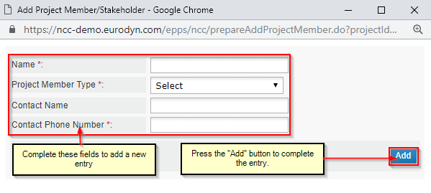
Figure 29: Add Project Team/Stakeholder

- Project Locations
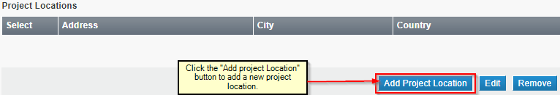
Figure 30: Project Locations View

In this section, the fields that a user can complete are the following:
- Address
- City
- Country (Mandatory)
The fields can be seen as in the following figure ( Figure 31: Add Project Location Fields).
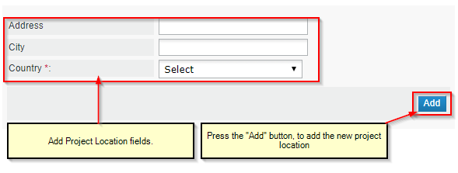
Figure 31: Add Project Location Fields

*All of the previous sections have the options of editing and removing items already added.
After completing all the previous, the Projects Profile tab is now completed.

Fill in the “Personnel Profile” tab
When the user goes to the Personnel Profile tab, in order to complete all the information required for this profile, they see the following image when entering for the first time.

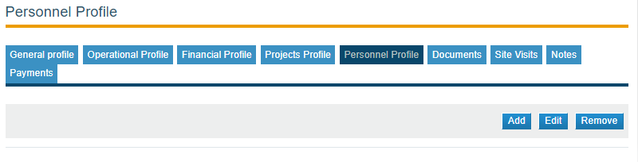
Figure 32: Personnel Profile

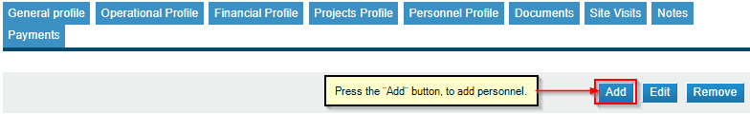
Figure 33: Press the "Add” button to add personnel profile

In this section, the fields that a user can complete are the following:
- Name (Mandatory)
- Role/Title (Mandatory)
- Role/Type (Mandatory)
- Nature of Employment (Mandatory)
- Status
- Start Date
- Calendar
- End Date
- Calendar
- Business Contact (Mandatory)
- Taxpayer Registration Number (TRN)
- National Id (Mandatory)
- Background Summary (Mandatory)
- Phone number (Mandatory)
- Years with Firm (Mandatory)
- Years in Industry (Mandatory)
The fields can be seen as in the following figure (Figure 34: Add Personnel Fields).

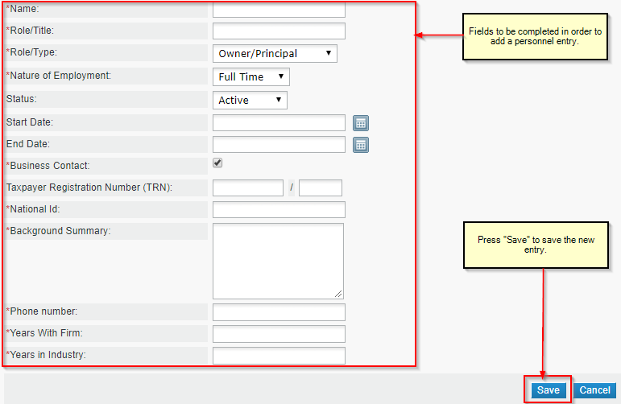
Figure 34: Add Personnel Fields

After completing and saving the fields for the new personnel entry, user must select the entry and press “Edit”. Then they will see a new set of section appearing under the specific personnel entry.

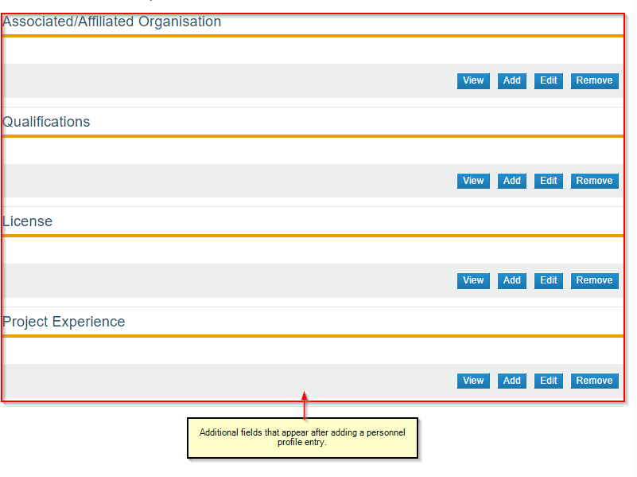
Figure 35: Additional Personnel Profile Entries

- Associated/Affiliated Organization

When a user presses the “Add” button, new fields appear to be completed.
These fields are:
- Name (Mandatory)
- Position Held (Mandatory)
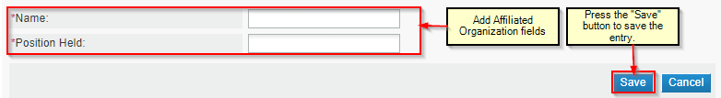
Figure 36: Associated/Affiliated Organization fields

- Qualifications
When a user presses the “Add” button, new fields appear to be completed.
These fields are:
- Qualification (Mandatory)
- Discipline (Mandatory)
- Year Qualified (Mandatory)
- Institution (Mandatory)
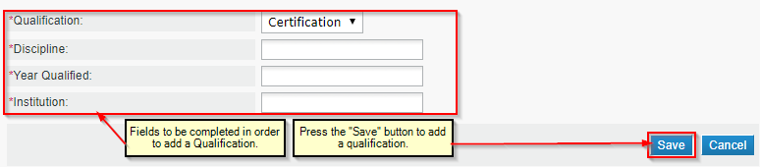
Figure 37: Add Qualification fields

- License

When a user presses the “Add” button, new fields appear to be completed.
These fields are:
- Description (Mandatory)
- Licensing Body (Mandatory)
- Issue Date (Mandatory)
- Expiry Date (Mandatory)
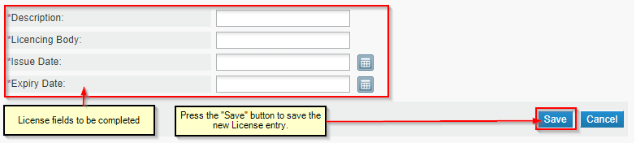
Figure 38: Add License Fields

- Project Experience

When a user presses the “Add” button, new fields appear to be completed.
These fields are:
- Category Applied To
- Years of Experience in Category
- Work executed as
- Project Name
- Project Location
- Contract Period
- Contract Start Date
- Contract Completion Date
- Description of Work
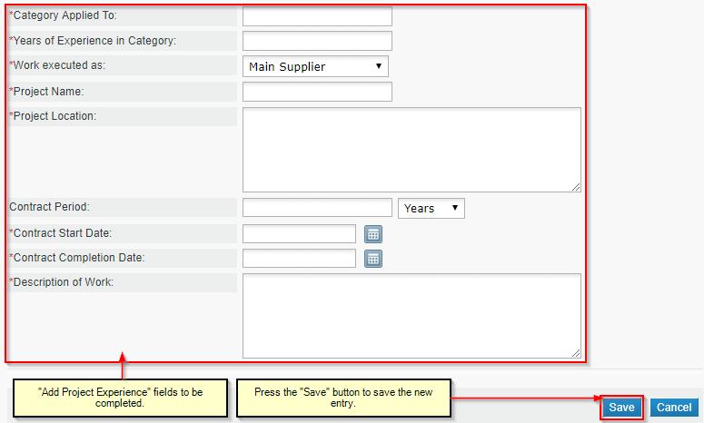
Figure 39: Add Project Experience fields

*All of the previous sections have the options of editing and removing items already added.
After completing all the previous, the Personnel Profile tab is now completed.

“Documents Profile” tab
When the user enters the Documents Profile tab, they see the following (in case there is no document added, as we are in the registration process):

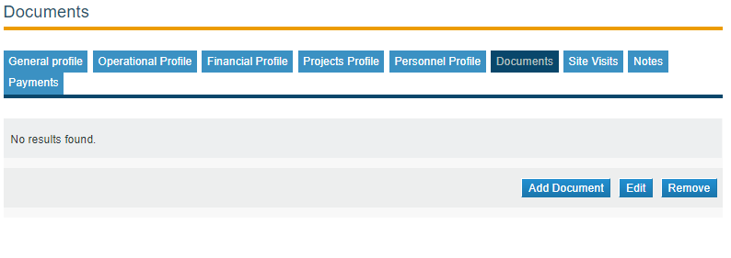
Figure 40: Documents Profile tab view

The Documents profile, can have documents added right away, or can have documents added during the Application for a New Registration Process.
If a user wants to add document, they must press the “Add Document Button” and then they will see the following window:

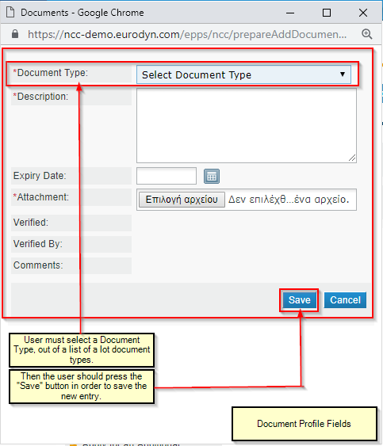
Figure 41: Add a document window

*All of the previous sections have the options of editing and removing items already added.

“Site Visits” tab

A Supplier Administrator user, cannot add a Site Visit. This is an action that can be done by PPC users.
Supplier administrator can only view a Site Visit, when added by PPC users.

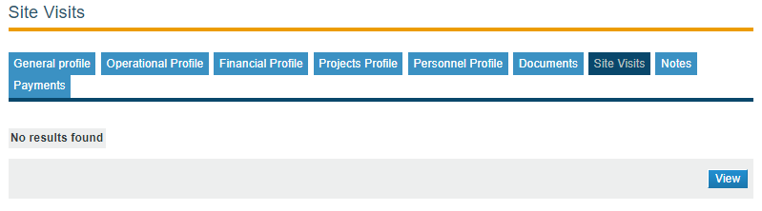
Figure 42: Site Visits tab

“Notes” tab
A Supplier Administrator user, cannot add a Note. This is an action that can be done by PPC users. Supplier administrator can only view a Note, when added by PPC users.

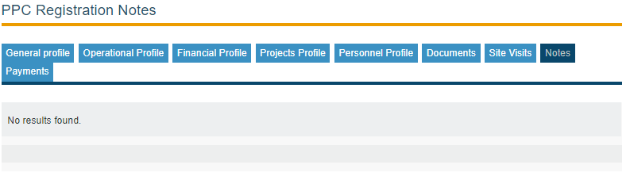
Figure 43: Notes tab

“Payments” tab
Only Suppliers that wish to apply for a Works Category will be required to complete a payment to activate their registration. Suppliers are required to make online or offline payments relating to their registration activities.
There are three (3) types of payments:
- Initial Subscription – Initial payment for a PPC registration approval/activation fee regarding a supplier registering for the first time within the PPC module.
- Renewal - The PPC registrations are subject to renewal every 3 years, so that Suppliers are allowed to retain their registrations status and be able to participate in tenders. The renewal is associated with a respective renewal fee.
- Grade Modification – Works upgrade payment
Only shows entries, if there is an entry already added. If no payment is already added, there won’t be any data at the time being.

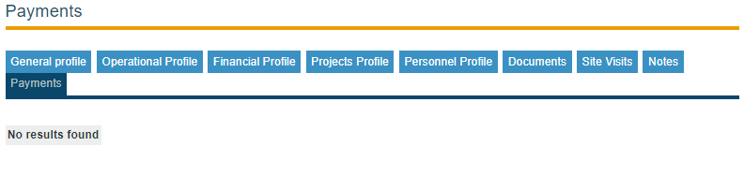
Figure 44: Payments tab

Apply for a New Registration Process
When a Supplier Administrator user completes the PPC Profile, they can apply for a new Registration.
This is where the user must go, in order to enter to the Application Form Page:

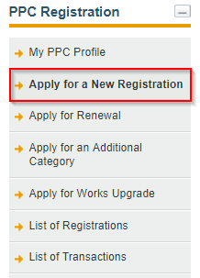
Figure 45: Apply for a New Registration Option

When the user is on that specific page then they can see the following fields to be completed:
- Class (Mandatory)
- Competition (Mandatory)
- PE (Mandatory)
- Registration Type (Mandatory)
- Categories (Mandatory)
This is what a user sees in this page, as seen in Figure ( Figure 46: Apply for a New Registration fields to be completed).

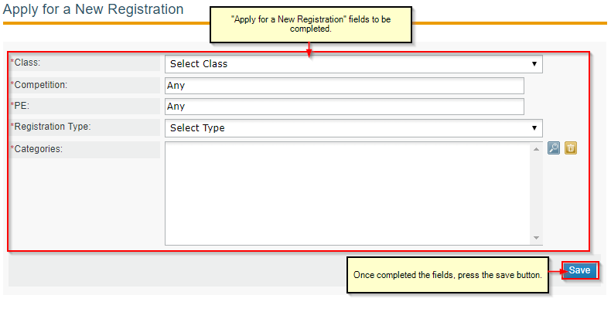
Figure 46: Apply for a New Registration fields to be completed

After Applying for a New Registration, the Confirmation Request is sent to the Supplier, the Supplier will have the options to “Review Final Recommendation”, “Confirm Recommendation” and “Decline Recommendation”. If the Supplier selects “Review Final Recommendation”, they will see the Note that the PPC Coordinator created in a previous step. If the Supplier selects “Decline Recommendation”, the registration transaction status will be changed to “Withdrawn” and the flow with continue with the “Recommendation of Cancellation”.
If the Supplier selects “Confirm Recommendation”, in case the category is Works (1-4) or Works (5), a message to complete Payment will appear. Then, if Payment completed, the Transaction Status will be set to “Confirmed”.

Apply for renewal
The supplier admin user will be able to renew an existing registration by selecting the “Apply for renewal” button under the details page of an existing registration. The “Application for renewals” option will be available for “Valid” and “Expired” registrations. The Supplier Administrator user must select the option seen in the figure (Figure 47: Apply for Renewal option).

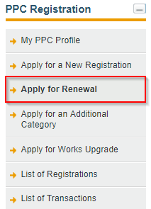
Figure 47: Apply for Renewal option

- Then the following screen will appear (Figure 48: Renewal screen):

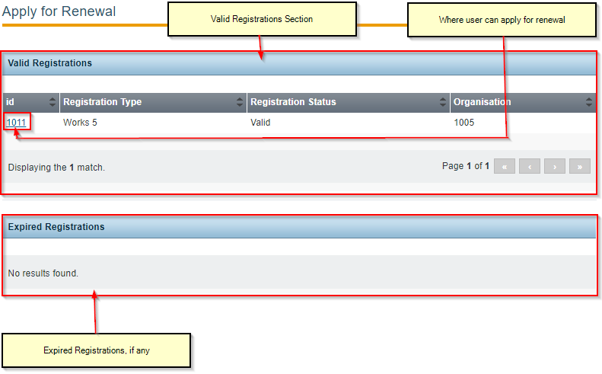
Figure 48: Renewal screen
User must select the ID field and then the next step would be the Application for Renewal.

- This Application for Renewal will be done as described in this figure (Figure 49).
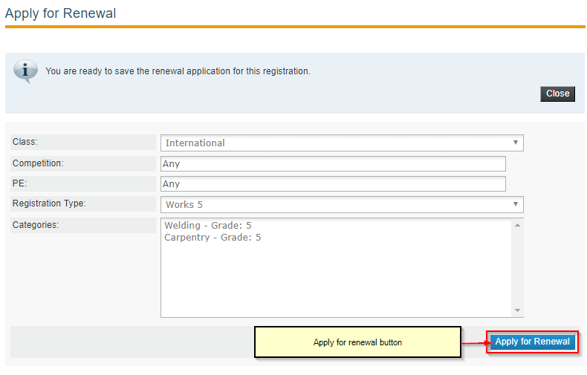
Figure 49: Apply for renewal final

During the renewal and later the assessment process, the Supplier should confirm the decision, and if the registration type of the renewal is “Works”, they will have to complete the associated payment. Upon confirmation and completion of the payment (if applicable), the transaction status is changed to “Confirmed”.

Apply for an Additional Category
The supplier admin user will have the option to apply for an additional category by selecting the “Apply for Additional Category” link under the PPC registration menu.
Addition of categories will be allowed for “Valid” registrations and only if there is a minimum of one hundred and eight (180) calendar days remaining on the validity of the registration.
This is where the user must go, in order to enter to the Application Form Page:

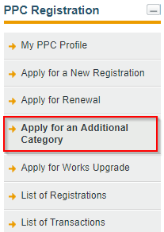
Figure 50: Apply for an Additional Category option

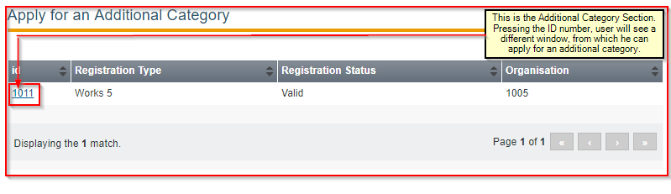
Figure 51: Apply for an Additional Category Section

- Then the following screen will appear (Figure 52):

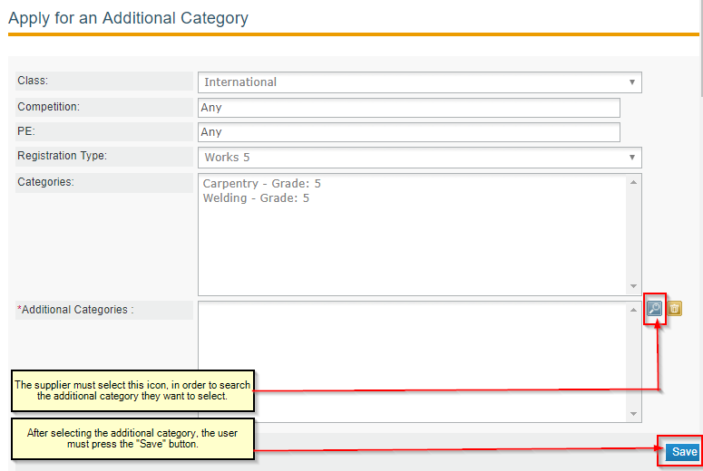
Figure 52: Additional category selection

- This Application for additional category will be done as described in this figure (Figure 53):
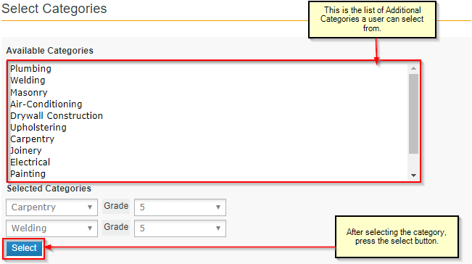
Figure 53: Where to select categories

During the Application for Additional Category and later the assessment process, the Supplier should confirm the decision, and if the registration type of the renewal is “Works”, they will have to complete the associated payment. Upon confirmation and completion of the payment (if applicable), the transaction status is changed to “Confirmed”.

Apply for Works Upgrade
The supplier admin user will have the option to apply for a different grade in a “Works” category for which they have a valid registration, by selecting the “Apply for Works Upgrade” link under the PPC registration menu.
Works upgrade will be allowed for “Valid” registrations and only if there is a minimum of ninety (90) calendar days remaining on the validity of the registration.
This is where the user must go, in order to enter to the Application Form Page:

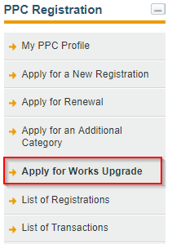
Figure 54: Apply for Works Upgrade Option

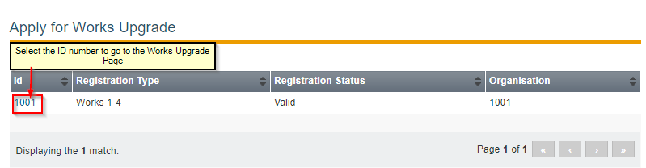
Figure 55: What to select in order to apply for a new registration

Then the following screen will appear (Figure 56):
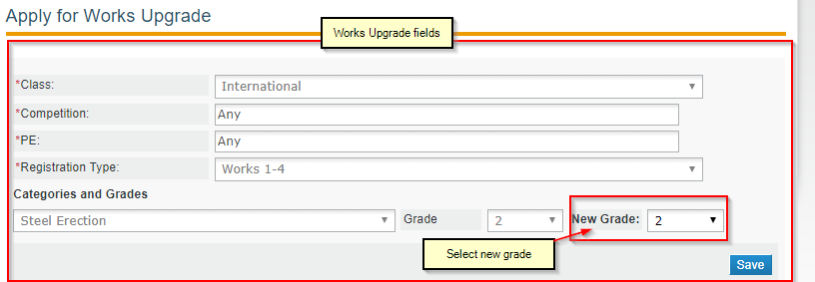
Figure 56: Apply for Works Upgrade

In case the grade requested is greater than the recommended grade, the user sees the following message (Figure 57):

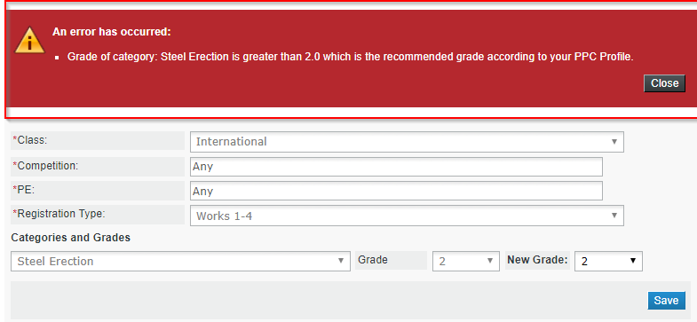
Figure 57: Error in grades recommendation

During the Application for Works Upgrade and later the assessment process, the Supplier should confirm the decision, and if the registration type of the renewal is “Works”, they will have to complete the associated payment. Upon confirmation and completion of the payment (if applicable), the transaction status is changed to “Confirmed”.

List of Registrations
The Supplier Administrator users will have access to the “List of Registrations” option under the PPC Registration Menu, which will display a list of registrations of the supplier organization.
Only registrations with statuses “Valid”, “Expired”, “Suspended” and “Cancelled” will be displayed under this page. Unapproved registrations will not be displayed under the list of registrations.
Suppliers can see the Active Registrations and export the list to PDF or CSV.

This is where a user Supplier can find the list of Registrations (Figure 58):

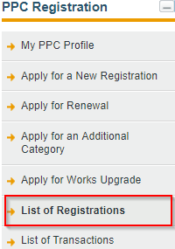
Figure 58: List of Registrations option

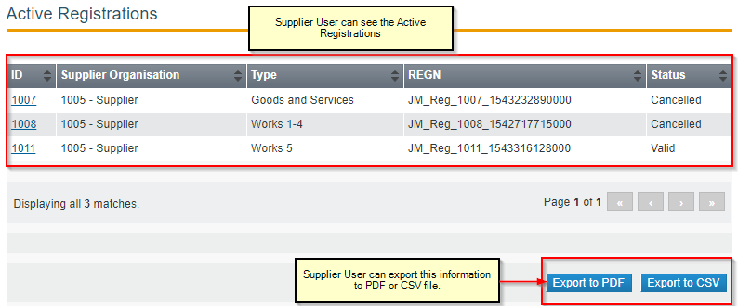
Figure 59: List of Registrations

List of Transactions
Every action that relates to a new registration or the modification of a registration (i.e. renewal, withdrawal or addition of new categories to an active registration) will be dealt as a separate “Transaction” in the system and thus will be assigned a unique identifier (i.e. a “Transaction number”).

This is where a user can see the option for the list of Transactions (Figure 60):
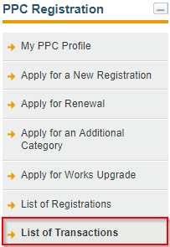
Figure 60: List of Transactions option

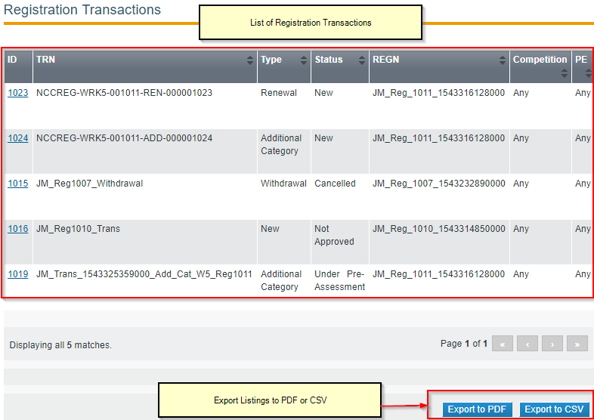
Figure 61: List of Transactions

